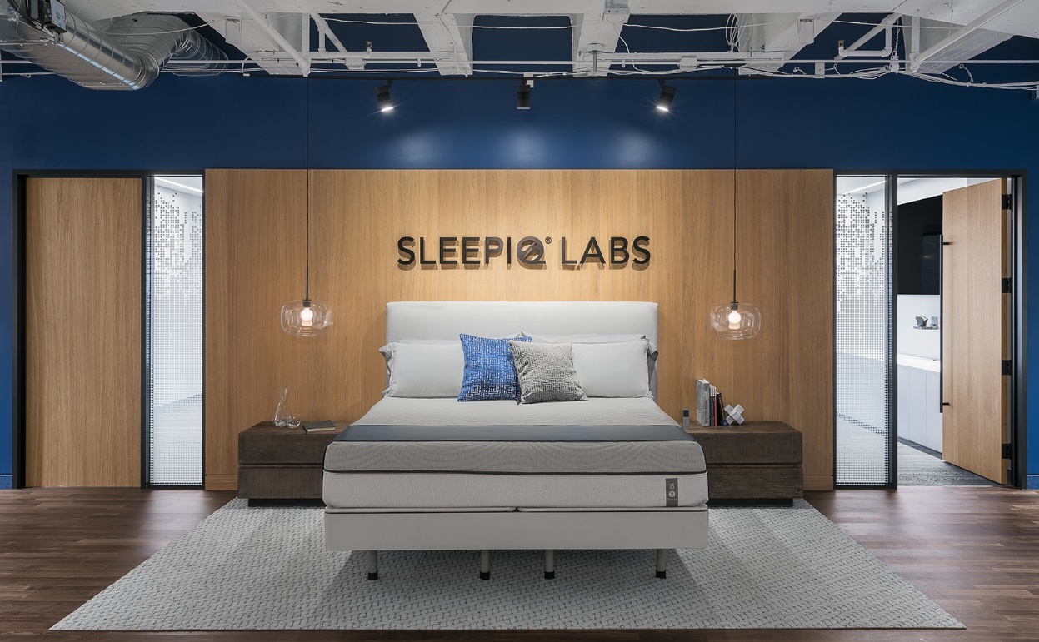

**Proposal For**

**“The Sleep Labs”**

**Proposal Submitted By:**

Pooja Patil

M: +91 8319083372

E: poojapatil2944@gmail.com

Date: 14-feb-2023

**The Challenge**

* **The sleep labs , who wants to reach out to maximum people of**  Nawada Fatehpur, Gurgaon ,Haryana

**Solution for Facebook profile**

* We have to do work for more followers for more awareness
* We should do post image/video with relevancy content & awareness
* We must add official website line on Facebook profile & add page name

**Solution for twitter profile**

* We should add website link on twitter profile
* We have to do work for more followers for more awareness
* We should do post image/video with relevancy content

**Solution for LinkedIn profile**

* No associated LinkedIn profile found linked on your page.
* We should add website link on linkedIn profile
* We have to do work for more followers for more awareness
* We should do post image/video with relevancy content

**Solution for you Tube profile**

* No associated YouTube channel found linked on your page.
* We should add website link on you Tube profile
* We have to do work for more followers for more awareness
* We should do post image/video with relevancy content

**Scope of Work**

**Social Media Management**

* Enhance your profile, so it can reach.
* Post updates on work being done by the sleep labs
* Join multiple Facebook groups (like sleep labs) & share updates on those groups.
* We will target to get around more followers on the Facebook page of sleep labs Group.



**Social Media Advertisements**

* Creating Facebook ads, Instagram Ads.
* Targeting Facebook Ads to a particular targeted group.
* Using sponsored Posts & Ads to increase page likes & post engagements.
* A/B/C testing of Ads.
* Monthly Ad reports**.**

**Coordination we will need from your end:**

* We would need updates from your end, regarding the work being done by sleep labs Group.

**About website optimization option**

#### Meta Description Tag

* our website should have meta description tag Your page has a meta description tag however, your meta description should ideally be between 70 and 160 characters (including spaces)

A meta description is important for search engines to understand the content of your page, and is often shown as the description text blurb in search results.

**H1 Header Tag Usage**

* Your website have a H1 Header Tag.

The H1 Header Tag is an important way of signaling to search engines what your content is about, and subsequently the keywords it should rank for.

**Keyword Consistency**

* Your website should have a keywords for HTML tags. Your page's main keywords are not distributed well across the important HTML tags.

Your page content should be focused around particular keywords you would like to rank for. Ideally these keywords should also be distributed across tags such as the title, meta and header tags.

**Image Alt Attributes**

* You have to add alt tag on your images.
* We found 25 images on your page and 14 of them are missing the attribute.
* Alt attributes are an often overlooked and simple way to signal to Search Engines what an image is about, and help it rank in image search results.

**Website Page Speed Insights – Mobile**

* Google is indicating that your page is scoring poorly on their Mobile Page Speed Insights evaluation.

Google has indicated that the performance of a webpage is becoming more important from a user and subsequently ranking perspective.

**pages with keyworks**

* must be keywords by page your website keywords is missing

**Email privacy page speed**

* email addresses and replacing them with images or contact forms. Plain text email addresses can be susceptible to scrapers and email spammers.

**page speed**

* your website page loads speed in slowly so you have to optimise

**Local business**

* No Local Business Schema identified on the page.

**Friendly Links**

* Some of your link URLs do not appear friendly to humans or search engines.

We would recommend making URLs as readable as possible by reducing length, file names, code strings and special characters.

#### Tap Target Sizing

* Some of the links or buttons on your page may be too small for a user to easily tap on a touchscreen.

**Errors (29)**

* Our website has a (29) errors & warnings is (5) so you have to fix it

### Your website could be better

## 

Top of Form

Bottom of Form